**du command:**

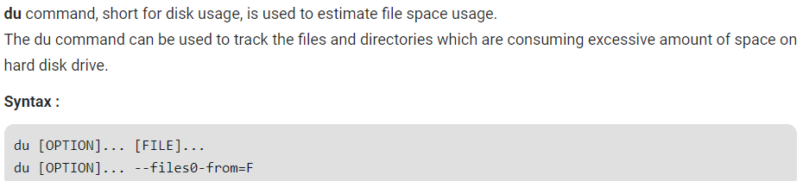

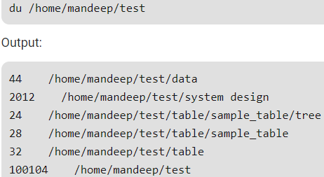

**Options:**

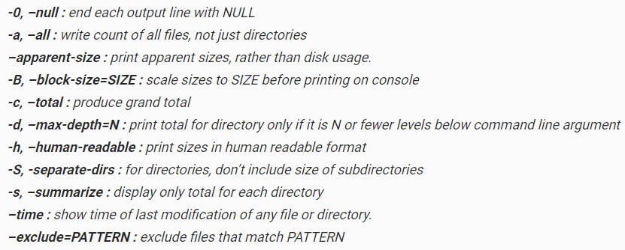

**Examples:**

Just **“du”** command will display the size of each file of current directory and the files in sub directories as well and also in bytes

If we want the same data to print sizes in human readable format (**K, M, G), use -h** option

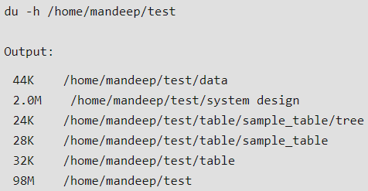

Use **-a** option for printing all files including directories.

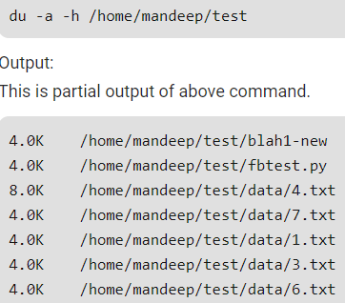

Use **-c** option to print total size

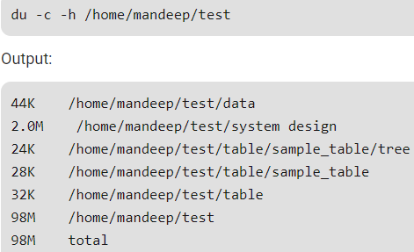

To print sizes till particular level, use **-d** option with level no

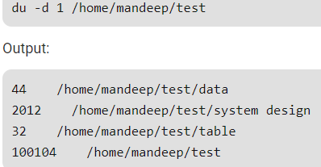

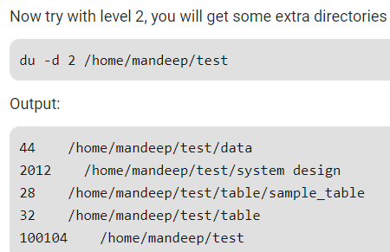

Get summary of file system using **-s** option. It displays the size of whole current directory.

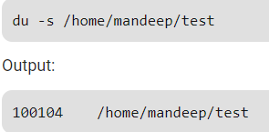

Get the timestamp of last modified using **--time** option

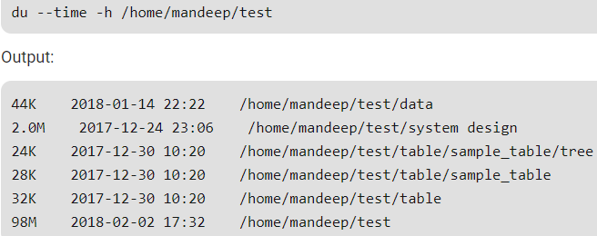

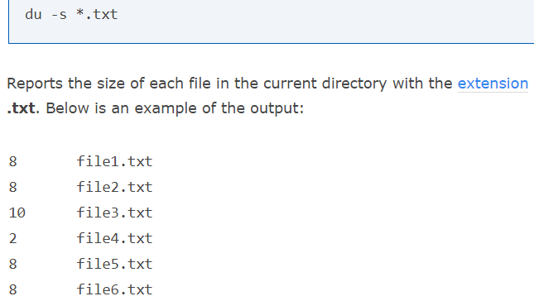

As above, if we use * it will consolidate and displays the size of each file and folders in human readable format.

